## **Map 1: Solar Panel-Related Complaints Submitted to the Texas Attorney General**

## **Rate Per 10,000 County Population**

## January 1, 2018 to June 30, 2024*

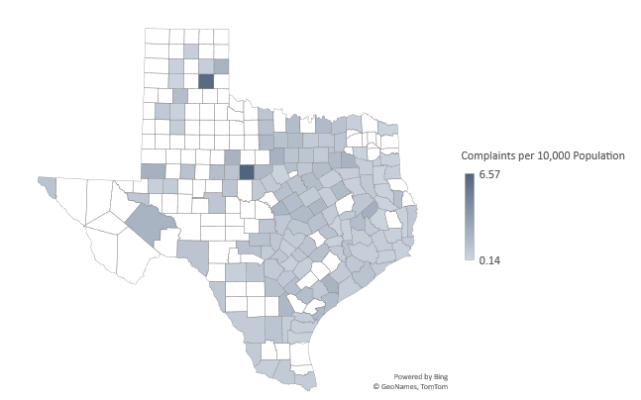

*McMullen County is excluded from the map as an outlier. It has a rate of 33 complaints per 10,000 people. McMullen County has a population of 600, and there were two complaints submitted. County population data is from the 2022 1-Year American Community Survey. Complaints data is from a Texas Appleseed analysis of solar panel-related complaints accessed through open records requests submitted to the Texas Office of the Attorney General. The complaints cover a period from January 1, 2018 to June 30, 2024.